Plates with creativity, colour, health and happiness
After a life-changing medical experience, Joanne Wood, aka The Balanced Kitchen, decided to have a complete overhaul of her diet and now shares her experiences and recipes with others.
For Joanne, food is about much more than sustenance and she believes it can bring creativity, colour, health and happiness to our lives.
Below she shares a delicious healthy meal, which has been created to reflect the vibrancy and excitement of Spring.
PEA, MINT & TOASTED PINE NUT PATE
This colourful pate tastes as fresh as it looks and kick starts this Spring meal with an air of excitement.
Serves: 6
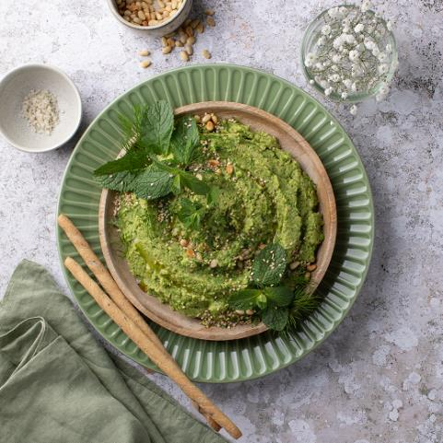
INGREDIENTS:
- 1 small brown onion, peeled, diced small
- 150g fresh or frozen peas (thawed), reserve some for serving (optional)
- 400g tin of chickpeas, rinsed (drained weight 230g)
- Large handful fresh spinach, washed
- 2 large cloves garlic, peeled
- 50g tahini paste
- Salt & Pepper
- Large sprig of fresh mint leaves, washed – reserve some for serving
- 20g pine nuts, lightly toasted
- Small handful dill and sesame seeds for serving
METHOD:
- Place the diced onion with a dash of oil or water into a small frying pan with a lid and cook over a low heat until they become soft and translucent (5-10mins).
- Remove the cooked onions from the heat and pour into a food processor.
- Add the peas, drained chickpeas, spinach, garlic, tahini, seasoning and mint leaves (reserve some for serving if desired).
- Pulse until smooth and creamy.
- Transfer the mixture into a serving dish and top with the toasted pine nuts, extra mint leaves, dill and sesame seeds.
- Serve with breadsticks or raw, sliced vegetables.
Please note: pates are not recommended for pregnant women

TURMERIC, THYME & TOMATO WITH RED ONION VEGAN QUICHE
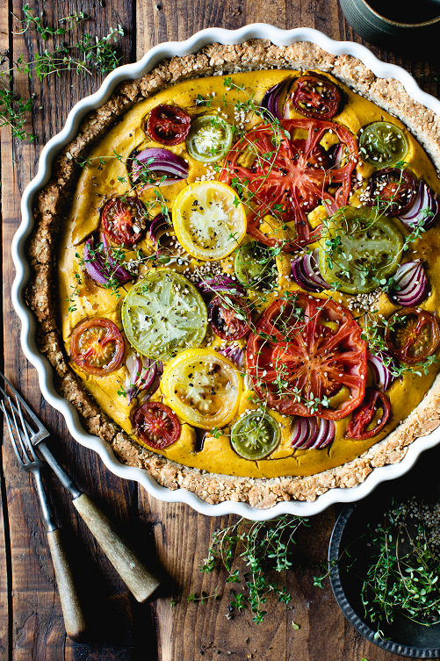
The vibrancy continues with this stunning show stopper of a tart, which doubles up as a nutritional powerhouse of a main course.
Serves: 6

INGREDIENTS

BASE
- 200 g buckwheat flour
- 150 g oats
- 100 g hazelnuts ground
- 40 g sesame seeds
- 100 g coconut oil melted
- 1/2 cup gram flour
- 1 TBSP xylitol sugar alternative (available as Total Sweet)
- 1/2 cup water
- 1 grind sea salt

FILLING
- 1 block firm tofu 396g net weight, drain
- 150g gram flour
- 250ml water
- 1.5 tsp wholegrain mustard
- 30g cup nutritional yeast flakes
- 1/2 tsp kala namak salt optional
- 1 clove garlic peeled
- 1 TBSP of turmeric

TOPPING
- a selection of your choice of tomatoes - enough to cover the surface of the quiche. I used 5-6 of different sizes. slice larger ones and halve the smaller ones
- 2 red onions sliced

EXTRA
- 1 TBSP balsamic vinegar
- 5 sprigs fresh thyme
- 1 TBSP sesame seeds

INSTRUCTIONS

BASE
- Process the hazelnuts to a fine crumb texture in a food processor. You could sub the hazelnuts for almonds or ground almonds.
- Then pour the ground hazelnuts into a large bowl and add the buckwheat flour, oats, sesame seeds, gram flour and salt.
- Melt the coconut oil gently in a pan and add the xylitol. Gradually pour the melted mixture over the flour mixture and work quickly with a spoon to mix until you reach a crumb-like texture and no dry flour remains - scrape down the sides of the bowl until all ingredients are combined.
- Now, add the water and continue to stir and combine well.
- Pour the mixture into the flan baking dish (my dish measures 35cm dia - adjust the quantity of the ingredients to suit your size of dish).
- Press the mixture flat and up the sides of the dish until evenly spread. Smooth out with the back of a spoon.
- Bake the base blind (without the filling) in a pre-heated oven for 10 minutes.
- Remove from the oven ready for the filling.

FILLING
- While the base is baking in the oven. Wash out the food processor jug (if used from the hazelnuts). Add the drained tofu, gram flour, mustard, nutritional yeast flakes, kala namak salt (if using), garlic, turmeric and water.
Process until smooth.
- Pour the filling into the base and smooth out using the back of a spoon or spatula.
- Top with the sliced red onion and tomatoes, ensuring the topping is generous to provide maximum flavour per slice!
- Bake in the oven for a further 20-25mins until baked through and turning golden.
- Remove from the oven and add sprigs of fresh thyme, a drizzle of balsamic vinegar and a scattering of sesame seeds before serving.

RECIPE NOTES
Serve alone or with green salad leaves.

Upside-down Almond, Orange & Coconut Cake
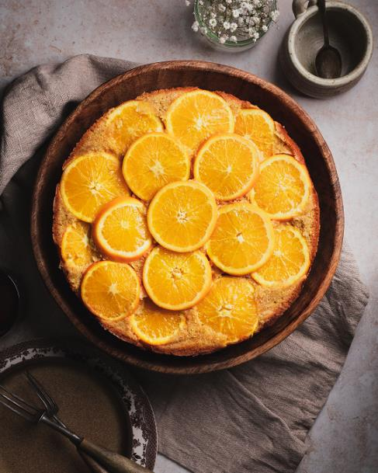
Keeping the feel good vibe going to the end is this beautiful desert. Light enough to ensure you don’t feel too full, but still warming and comforting (until the summer sun arrives).
Serves: 10
(23cm springform tin)

INGREDIENTS:
- 3 small oranges – sliced thinly
- 200g softened butter (150g for the cake, 50g for oiling the baking paper)
- 100g xylitol
- 4 large eggs, beaten
- 50mls plain yoghurt
- 150g spelt wholemeal flour
- 120g ground almonds
- 2 TBSP desiccated coconut
- 2 level tsp baking powder

METHOD:
- Start by lining the bottom of the tin with the baking paper.
- Using a clean paper towel, spread 50g of the softened butter on top of the baking paper in the tin.
- Arrange the sliced orange slices, starting from the middle and working towards the edges, overlapping as needed to cover the bottom of the tin. Set to one-side while you make the cake mixture.
- Cream the remaining softened butter and xylitol together in a bowl.
- Add the beaten eggs and yoghurt and whisk until incorporated.
- Next, gradually whisk in the spelt flour, ground almonds, desiccated coconut and baking powder until you reach a smooth batter consistency.
- Gently pour the batter on top of the arranged orange slices and spread evenly. It may help to pour the mixture in 4 sections and using a spatula to gently smooth the batter over the oranges, so as not to disturb them.
- Bake in a pre-heated oven at 180 degree C (160 degrees fan oven) for 45mins. Place a piece of foil over the cake during the last 10-15mins if it begins to brown too much.
- Remove from the oven, allow to cool for 15mins.
- Once cooled, release the spring- release and lift away the edges from the tin.
- Place a plate on top of the cake and quickly turn the cake so that the oranges are now on the top. Carefully peel the baking paper off to reveal the cake.
- Best eaten on day of making. If you store any uneaten cake in the fridge and find it has soaked up the juice from the orange slices, you can re-heat the cake for10-15mins to help dry it out again.

